2024 He-Young Kimm Cup

International Han Mu Do Tournament

Official Rules of Competition

Introduction
The following are the Official Rules of Competition for the 2024 He-Young Kimm Cup International Han Mu Do Tournament.

Uniform, Equipment, and Hygiene
All contestants must wear a clean Han Mu Do dobok (uniform). Dae Ryun (sparring) competitors are required to use a mouthpiece, hand, shin and foot padding as well as protective gear for the head, face shield may be used but not required, and ho gu (chest protector). Male contestants are required to wear a groin protector.

Contestants may not wear jewelry of any kind while participating in the competition. Contestant's fingernails and toenails must be clean and neatly trimmed.

Event Coordination
A tournament director will be assigned to coordinate and supervise each event and contest area. Responsibilities of a director include ensuring that the rules described in this document are adhered to, notify contestants of their time to participate, and act as an arbiter for any disputes or appeals.

Dae Ryun - Free Sparring Competition

General Information
Contestants will be matched with another of similar rank and experience for free sparring competition. The match is officiated by one referee and two judges. The contestant who receives the most points in a 2-minute match is the winner of the match and moves on to the next round of competition. The contestant who receives the most points in the final match will be declared the winner of the event.

Eligibility for participation
Dae Ryun competition is open to those seven years of age and older.

Techniques Restrictions by age and rank
The following technical restrictions are placed on contestants based on age and rank groupings:

Juniors (aged 16 and below)

White, Yellow and Orange Belts
May only use kicking and striking techniques. May strike to the covered areas of the head. Kicks to the head, throwing, holding, choking, and armbar techniques are illegal.

Green, Blue and Red Belts
May only use kicking, striking, throwing, and holding techniques. Flying kicks to the head, choking, and armbar techniques are illegal.

Brown Belt and Up
May kick and strike to the covered areas of the head and use all legal techniques. Flying kicks to the head are illegal.

Adults (aged 17 or above)

White, Yellow and Orange Belts
May only use kicking and striking techniques. May strike to the covered areas of the head. Kicks to the head, throwing, holding, choking, and armbar techniques are illegal.

Green, Blue and Red Belts
May only use kicking, striking, throwing, and holding techniques. Flying kicks to the head, choking, and armbar techniques are illegal.

Brown Belt and Up
May kick and strike to the covered areas of the head and use all legal techniques.

Officials’ duties and responsibilities

Referee Role and Declarations
The main responsibilities of the center referee are to provide a safe competitive environment, to enforce the rules of competition and to exercise control over the contest area. Instructions given by the center referee must be strictly obeyed.

Other duties of the center referee are to award points for ground techniques, to give warnings and minus points for violations, to declare disqualifications, and to ensure the safety of the contestants. Points declared as time is called to end the match are admissible. The center referee can make the following declarations:

Beginning the Match
- Cha Ryut Attention
- Kyung Ye Bow
- Joon Bi Dae Ryun Ready Position
- Shi Jak Begin

Pausing and Resuming the Match
- Joong Ji Stop or Break Action
- Ba Ro Stop or Break Action
- Shi Gan Time Out
- Ke Sok Continue

Sweeps, Throws, Holds, Chokes and Armbars
- Sa Jum Four points awarded for a clean throw
- Ee Jum Two points awarded for partially executed throw or takedown, hold, choke, or armbar
- Nu ryu ki Hold initiated
- Chwi So Cancel call or judgement
- Pul Yo Referee declare hold broken

Penalties
- Kam Jum Minus Point
- Kyung Ko Warning
- Deuk Jum Decision

Ending the Match
- Keu Man Break Action because the match is over
- Cha Ryut Attention
- Kyung Ye Bow
- Seung Winner
- Ban Chik Seung Win by disqualification of opponent
- Woo Se Seung Win by decision
- Tae Jang Dismissed

Corner Judge Roles and Declarations
The main role of the corner judge is to declare points for contestants who perform legal standing techniques. Corner judges declare points by raising the hand with the clicker matching the color of the scoring contestant while depressing the clicker for the appropriate number of points scored. Points declared as time is called to end the match are admissible.

When the corner judge witnesses a successful execution of a flying kick, they will raise the hand holding the clicker with the color of the scoring contestant and click the appropriate number of points, two for body shots and four for head, must be eligible.

In the event the center referee issues a minus point to a contestant. The corner judges will award a point to the contestant’s competitor by clicking the appropriate clicker.
When the center referee declares points for throws, holds, armbars or chokes, the corner judges will add the appropriate points to the contestant identified by the center referee by clicking the appropriate points on that contestant’s clicker.

Corner judges, who wish to attract the attention of the center referee, may do so by raising their right hand to interrupt the action of the match. Corner judges can interrupt the action of the match if they witness an infraction not seen by the referee or if they disagree with referee's decision to give a warning, minus point or disqualification. In the event of an interruption in action, the contest officials should meet in private to resolve the issue causing the interruption.

Grounds for Declaration of Stoppage, Points, Warnings, Penalties, and Disqualification's

JOONG JI (stop or wait):
- when one or both contestants go out or are about to go outside of the contest area
- when one or both contestants perform or are about to perform a prohibited act
- when injury occurs to one or both contestants (time out is called)
- when there is no apparent progress in the match (in standing or ground work)
- when a throw is not initiated within three seconds of a grab
- During ground work, when one contestant assumes standing position and lifts his opponent
- From standing position, when one or both contestants performs or are about to perform a choke, strangle, or armbar
- when the referee sees an unsafe act or feels an unsafe act is about to occur
- when the referee deems that the action(s) of one or both contestants merit a stop or break in the match
- when the judge signals for the center referee's attention (time out is called)
- when the referee wishes to confer with the corner judges or tournament officials (time out is called)

IL JUM (One Point):
- Controlled punch to a legal scoring area
- Controlled kick to a legal scoring area

EE JUM (Two Points)
- Controlled flying kick (both feet in the air) to a legal scoring area
- Partially executed throw (takedown)
- Holding down your opponent for 5 seconds after referee declare NU RYU KI (hold)
- When executing a choke, hold, or armbar, causing your opponent to tap twice with hand or foot
- During ground work, when the referee fears injury to a contestant due to a legal hold, choke, or armbar is imminent

Sa JUM (Four Points)
- Clean throw (opponent lands with both his back and at least one shoulder touching the ground)
- Controlled flying kick (both feet in the air) to a protected head area. (Adult Black Belt only)

KYUNG KO (Warning):
- Intentionally preventing or avoiding action during the match (5 seconds)
- Intentionally going out of boundary area
- Intentionally showing your back to deny legal scoring areas to your opponent or to avoid confrontation
- Attacking with the Knee or Elbow
- Striking or kicking an illegal area
- Attempting to throw without preceding offensive or defensive kick or punch (i.e. Throws may only be attempted after a defense of a kick or strike or as part of a combination with a kick or strike)
- Attempting to perform an armbar or choke from a standing position
- Attempting an illegal take-down or throw
- Intentionally falling down
- Applying joint lock to a joint other than the elbow
- During ground work pushing your opponents face
- During ground work applying a pressure point
- Not adhering to the instructions of the referee
- Unsportsmanlike conduct by contestant or coach
- When a contestant, to stall for time, rearranges his uniform without permission from referee
- Excessive contact to a legal target

KAM JUM (One minus point)
Note: Two KYUNG KO (warning) points automatically turn into one minus point
- Kicking or striking your opponent when he is on the ground
- Striking or kicking an illegal area with strong force
- Intentionally executing techniques outside of the contest area
- Intentionally attacking after referee's declaration of JOONG JI (wait), KEU MAN (stop), or BA RO (return)
- Headbutting
- Suflex - When holding your opponent from behind, attempting to throw them backward so that they land on their neck or head
- Engaging in entangled or scissors leg lock
- Serious unsportsman-like conduct by contestant or coach
- Repeated disregard of Official’s instruction

Disqualification
- Flagrant disregard for the rules of competition
- Flagrant disregard for the safety of the opponent
- Intentionally trying to injure the opponent
- Flagrant disregard of Official's Instruction
- Repeated acts of unsportsman-like conduct by the contestant or coach

Match Outcomes

DEUK JUM (Decision)
- Win by most points
- Win by opponent's disqualification due to serious infraction of rules
- Win by opponent's forfeit due to their failure to appear
- Win by opponent's forfeit due to their giving up the match
- Win by default when opponent is injured at their own fault
- Win by superiority

Overtime
If at the end of the match, both contestants are tied in the number of points accumulated, the first to score is the winner of the match. The maximum length of the overtime period is one minute.

WOO SE SEUNG (Win by Superiority)
If both contestants are still tied at the end of the overtime period, the center referee and corner judges confer and vote for the contestant who displayed both superior techniques and superior sportsmanlike conduct. The contestant who receives the majority of the votes will be declared the winner.

Scoring, Non-Scoring, and Illegal Target Areas

Scoring Target Area
Strikes or kicks executed with moderate force to the protected head, chest, abdomen, and rib cage are eligible for scoring. Strike or kicks to the protected areas of the head that cause the head to rock or tilt back are considered excessive force and will result in a warning or disqualification.

Illegal Target Areas
Strikes or kicks executed to the face area, back and top of the head, back, knees, or groin area are illegal.

Legal Techniques

Son Sul or Striking techniques

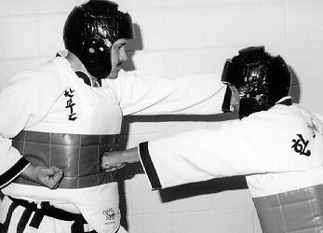
Front Punch
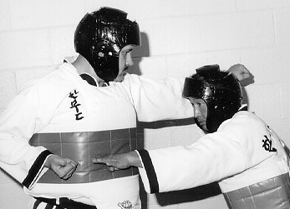
Ridge Hand
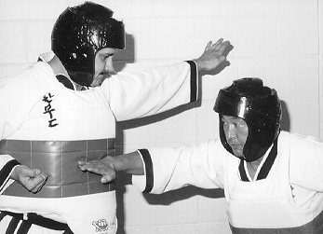
Knife Hand

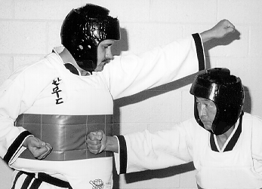
Back Fist
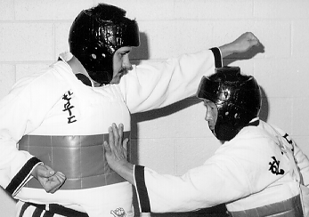
Palm Strike
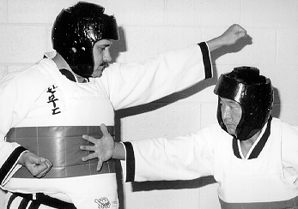
Reverse Palm Strike

Jok Sul or Kicking Techniques

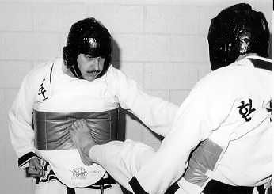
Front Kick

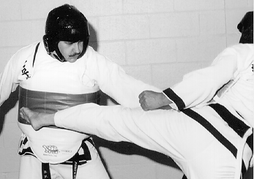
45° Kick

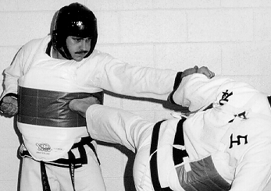
Side Kick
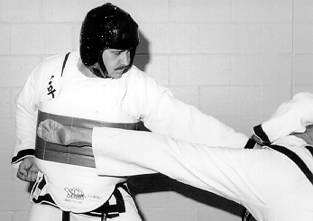
Roundhouse Kick

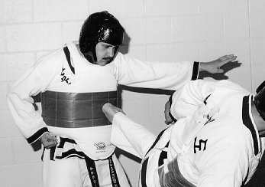
Back Kick

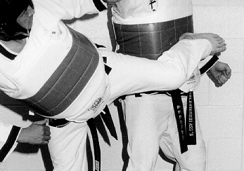
Hook Kick or Spin Kick

Meh Chi Ki Sul or Throwing Techniques

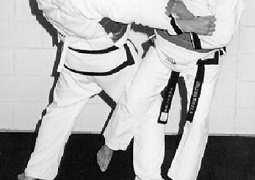
Major Outer Reaping Throw

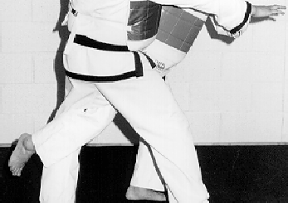
Major Inner Reaping Throw

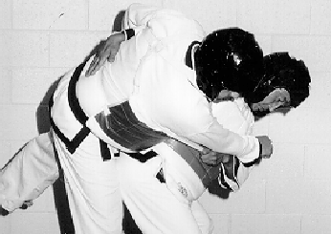
Major Hip Throw

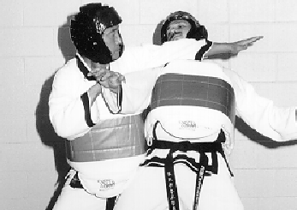
Scoop Throw

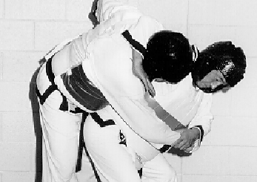
Neck Wheeling Throw

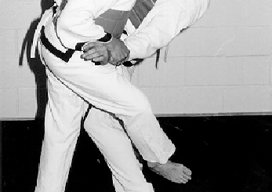
Major Outer Hooking Throw

Nu Leu Ki Sul or Holding Techniques

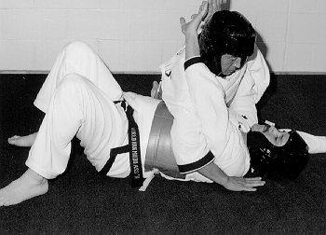
Cross Chest Hold

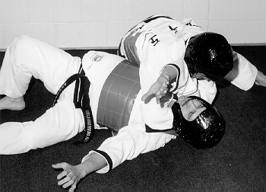
Shoulder Hold

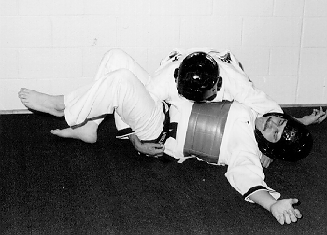
Side Four Corner Hold

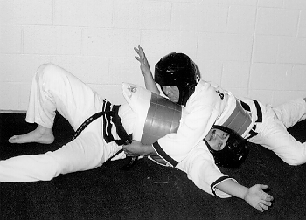
Modified Upper Four Corner Hold

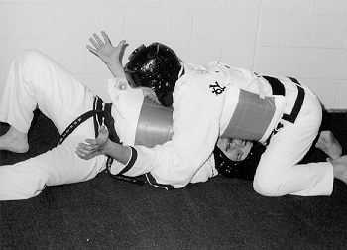
Upper Four Corner Hold

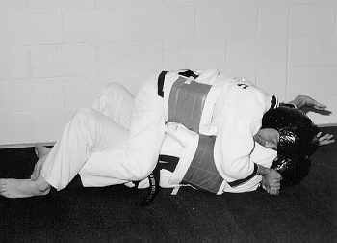
Longitudinal Corner Hold

Jo Leu Ki Sul or Choking Techniques

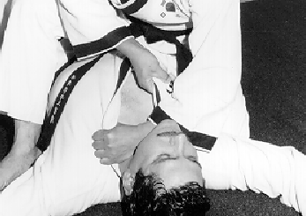
Half Cross Lying Choke

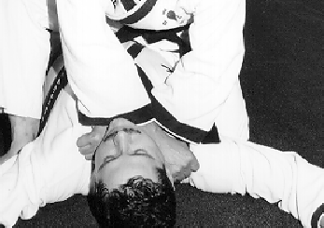
Normal Cross Lying Choke

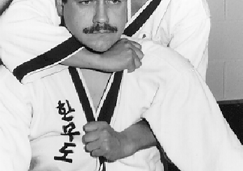
Half Cross Rear Choke

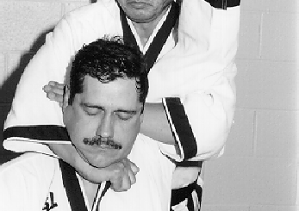
Modified Half Cross Rear Choke

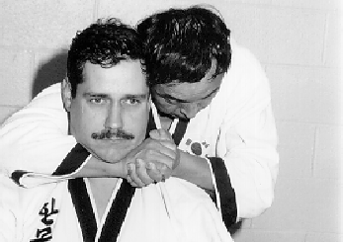
Naked Rear Choke

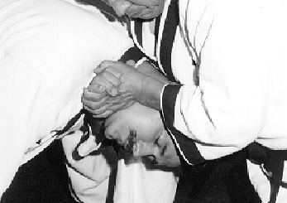
Naked Front Choke

Kguk Ki Sul or Armbar Techniques

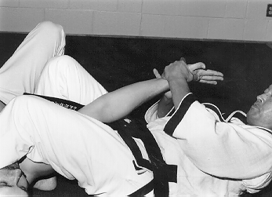
Cross Body Armbar

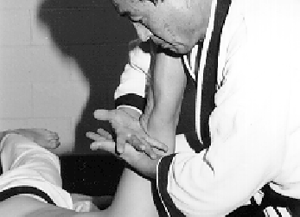
Shoulder Armbar

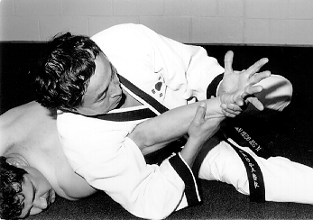
Armpit Armbar
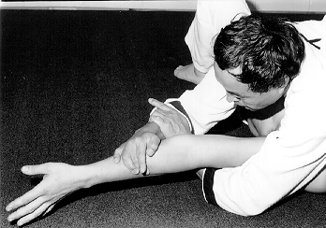Entangled Armbar I

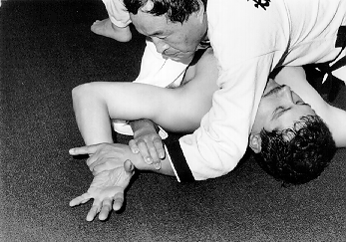
Entangled Armbar II

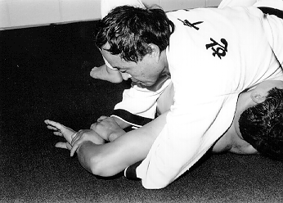
Entangled Armbar III

Appeals and Arbitration
A contestant may appeal a referee's decision if and only if he/she has been disqualified from competition. The appeal is made to the tournament director responsible for that contest area. The appeal must take place immediately after the action occurred. The contestant and his/her instructor may make the appeal.
The tournament director is to act as the arbiter for any appeals made during the course of competition. The tournament director is to meet separately with the contestant's party and officiating party before making his/her decision. The tournament director is bound by the rules of competition in his/her judgment of the appeal. The decision of the tournament director is final.

Hyung - Empty Handed Forms Competition

General Information
Contestants will perform the Hyung of their choosing before a panel of judges. The judges will assess a score to the performance. The contestant with the highest score in the competition will be declared the winner.

Eligible Hyungs
Contestants may perform the rank appropriate Hyung of their choosing. Rank appropriate means at their level or below.

Contestant's Etiquette and Performance of Hyung
Contestants will be called to perform Hyung before a panel of judges. They should acknowledge the notification verbally by stating "Yes Sir!" or "Yes Ma'am!" Contestants bow when they face the panel of judges. Before the start of their performance of Hyung, contestants should clearly state their name, the name of the Hyung and ask for permission to begin. After the completion of their performance, they should await the instruction of the chief judge and then exit the contest area.

Judges Role and Responsibilities
A panel of three to five judges will view each contestant's performance of Hyung. Each judge will view and evaluate contestant's performance of Hyung. Each judge will assess a score (based on ten-point scale) to each performance based on its technical and artistic merits. Head judge will declare “Deuk Jum” to receive the scores. Scores will be tallied and averaged. And the Head Judge declares Twe Jang to dismiss the contestant.

Ho Shin Sul - Self-Defense Competition

General information
Contestants will perform five techniques of their choosing before a panel of judges. The judges will assess a score to the performance. The contestant with the highest score in the competition will be declared the winner.

Eligible techniques
Contestants may perform five self-defense techniques that are appropriate to their rank level or below.

Contestant's Etiquette and Performance of Techniques

Red Belt and Below
Contestants will be called to perform their techniques before a panel of judges. They should acknowledge the notification verbally by stating "Yes Sir!" or "Yes Ma'am!" Contestant and their partner should enter the contest area and bow when they face the panel of judges with the contestant standing to the panel's right. Before the start of the performance of techniques, the contestant should clearly state their name, before asking for permission to begin. Contestants should perform the techniques in the manner in which they were taught (i.e. correct beginning stances, technique, and finish). After the completion of their performance, they should await the instruction of the chief judge and then exit the contest area.

Brown and Black Belts
Contestants will be called to perform their techniques before a panel of judges. They should acknowledge the notification verbally by stating "Yes Sir!" or "Yes Ma'am!" Contestant and their partner should enter the contest area and bow when they face the panel of judges. Before the start of the performance, contestants should clearly state their name, and ask for permission to begin. Contestants can perform the techniques in the manner in which they were taught (i.e. correct beginning stances, technique, and finish), but are encouraged to perform them in a realistic or demonstration style manner. After the completion of their performance, they should await the instruction of the chief judge and then exit the contest area.

Judges Role and Responsibilities
A panel of three to five judges will view each contestant's performance of Ho Shin Sul. Each judge will view and evaluate contestant's performance of Ho Shin Sul. Each judge will assess a score (based on ten-point scale) to each performance based on its technical and artistic merits.

Mu Ki Hyung - Weapons Forms Competition

Contestant Eligibility and General Information
Contestants will perform the weapons Han Mu Do Hyung of their choosing before a panel of judges. The judges will assess a score to the performance. The contestant with the highest score in the competition will be declared the winner

Eligible Hyungs
The following Hyungs are eligible for competition:
- Han Kum Il Hyung – Basic Sword Form
- Han Bong Il Hyung - Basic Long Pole Form
- Han Mu Bong Hyung - Beginner Long Pole Form
- Je Dok Kum Hyung - General's Sword Form
- Shin Sun Bong Hyung - Traditional Long Pole Form
- Bon Kook Kum Hyung - Traditional Korean Sword Form
- Ye Do Hyung - Advanced Traditional Korean Sword Form

Contestant's Performance of Mu Ki Hyung
Contestants will be called to perform Weapon's Hyung before a panel of judges. They should acknowledge the notification verbally by stating "Yes Sir!" or "Yes Ma'am!" Contestants should enter the contest area and bow when they face the panel of judges. Before the start of the performance of Weapon's Hyung, contestants should clearly state their name, name of Weapon's Hyung and ask for permission to begin. After the completion of their performance, they should await the instruction of the chief judge and then exit the contest area.

Judges Role and Responsibilities
A panel of three to five judges will view each contestant's performance of weapons Hyung. Each judge will view and evaluate contestant's performance of weapons Hyung.
Each judge will assess a score (based on ten-point scale) to each performance based on its technical and artistic merits.

Cup Championships

General information and eligibility
At the end of the competition, the adult and youth contestants with the best overall performance will be declared Grand Champion. In order to be eligible for this award, contestants must participate in Hyung, Ho Shin Sul and Dae Ryun.

Trophies Awarded
There are three trophies awarded at the end of each competition

Busby Cup
Awarded to the highest scoring adult competitor

Spencer Cup
Awarded to the highest scoring junior competitor

Chung Chul (Donald) Cup
Awarded to the highest scoring black belt competitor

Ties
In the event of a tie consideration will be given to the strength of field

Rules and situations not covered by this document
The governing body of this event will act upon any rules and/or situations not covered by this document. All decisions made by the governing body are final.
Referee’s and Judge’s Declarations for Dai Ryun

Cha Ryut Attention
Kyung Ye Bow
Joon Bi Dae Ryun Ready Position
Shi Jak Begin
Joong Ji Stop or Break Action
Ba Ro Stop or Break Action
Shi Gan Time Out
Ke Sok Continue
Nu ryu ki Hold initiated
Sam Jum Three points
Ee Jum Two points
Il Jum One point
Pul Yo Referee declare hold broken
Chwi So Cancel call or judgement
Kyung Ko Warning
Kam Jun Minus Point
Deuk Jum Decision
Keu Man Break Action because the match is over
Seung Winner
Ban Chik Seung Win by disqualification of opponent
Woo Se Seung Win by Superiority (Judge’s Decision)
Twe Jang Dismissed

